Wem  Safer Neighbourhood Team Newsletter | February 2024

Who are we?
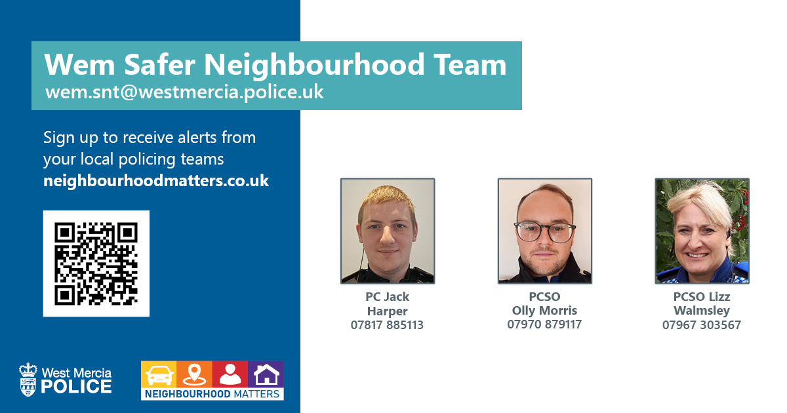

What’s Wem SNT been up to?
- Acting on community concerns raised by parish councils as part of the local policing charter.
- Speed Survey in Grinshill (18 vehicles surveyed 0 over the speed limit).
- Mobile Phone checks in Shawbury and Wem.
- Residential Care Home Visits

Dates for the Diary
- 29/02 – SNT Surgery at 10:00am in the Wem Library.

Local Incident Figures
Burglary - 3
RTC - 4
Vehicle Crime - 1
Highways Incident - 5
Assaults - 2
Domestic Incidents - 7

Concern for safety - 4
Anti-Social Behaviour - 1
Suspicious Circumstances - 3
Criminal Damage - 2
Theft - 1
Missing Persons - 0

Local Incidents
RTC in Wem – 15th February, Wem SNT alongside response officers attended a single vehicle RTC on Soulton Road, Wem.

Information
Scams –
Several different scams are doing the rounds in North Shropshire. We’ve had reports of phone scams and rogue traders.
- Rogue traders will target elderly residents to provide work on your home or garden and charge high amounts of money for little or no work. These callers will be looking to carry out ‘distraction burglaries.
- Phone scams include asking for your details over the phone i.e. pin numbers or passwords.

Nottingham Knockers –
There has been an increase in calls relating to Nottingham Knockers
- Nottingham Knockers relates to people who go door to door to sell items.
- Exclusively males with a chequered history.
- Informants will report that the knockers are persistent, rude, sometimes even aggressive and intimidating, known to target vulnerable members of our communities.

Community Speed Watch
How to join?
- Contact your local Safer neighbourhood team.
- Let SNT know where the issue is and speed.
- Have a coordinator and 6 volunteers to form a CSW.
What next?
- SNT will conduct a speed survey.
- Data collected from survey will be given to parish council or road safety team whether below or above speed limit.
Above threshold?
- Suitable volume of vehicles?
- Suitable for enforcement?
- Suitable site?
Road Safety Team
- Packs
- Training
- Data collection

Sign up to Neighbourhood Matters … your brand-new community messaging service
Neighbourhood Matters enables residents, businesses and community groups to keep in touch with local policing teams. You can choose exactly what type of alert you wish to receive and how you receive them; whether that be by email, text or telephone.
Sign up now at: www.neighbourhoodmatters.co.uk

